Day 2
Router and Switch Theory
1.Draw a labelled diagram of a typical home WiFi router and a network switch, clearly marking at least 3 different ports (such as WAN, LAN, Console) and the location of status LEDs.
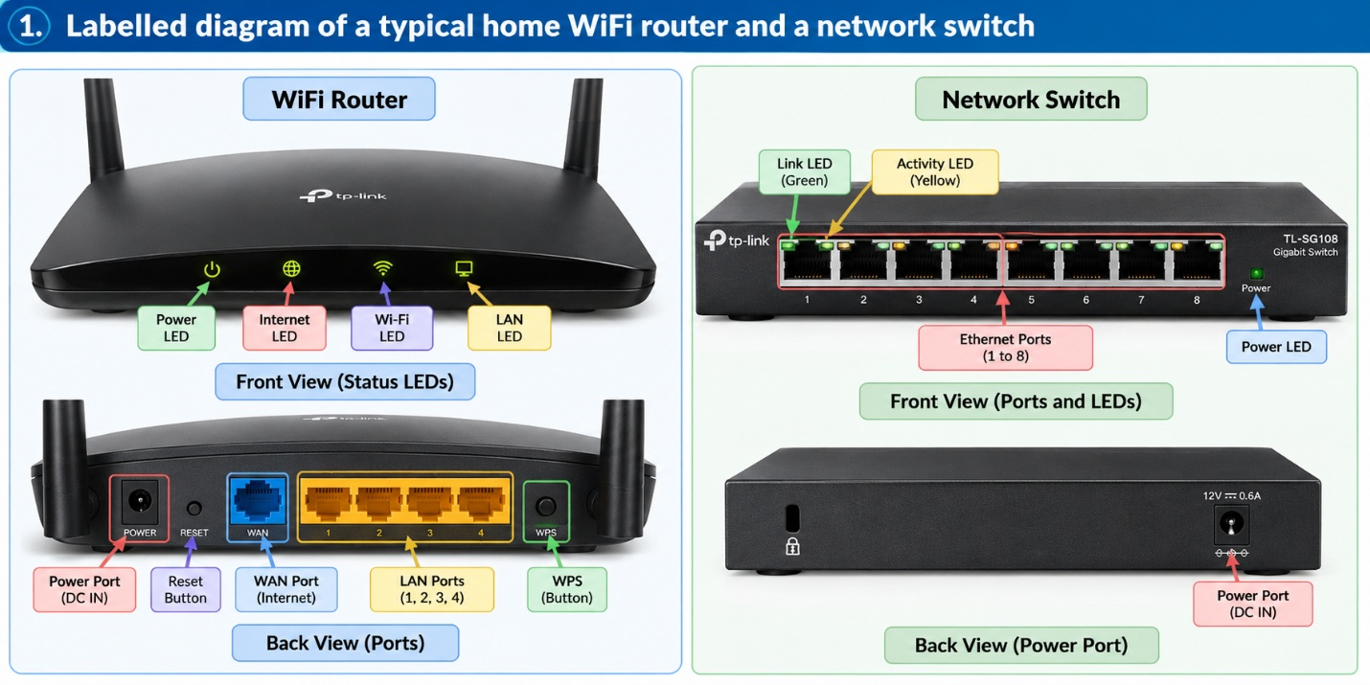
Task 1: Labelled Diagram of a Wi-Fi Router and Network Switch
The image above shows a complete labelled diagram of a typical home Wi-Fi router and a network switch, including their front and back views.
Explanation of the diagram
A. Wi-Fi router
- WAN port: Connects to the modem or internet connection.
- LAN ports (1–4): Connect computers and other wired devices.
- Power port: Supplies electrical power.
- Status LEDs: Indicate power, internet, Wi-Fi, and LAN activity.
- Reset button: Restores factory settings when used as instructed by the manufacturer.
- WPS button: Helps connect compatible wireless devices.

B. Network switch
- Ethernet ports (1–8): Connect computers and other network devices.
- Link LED: Indicates an established network connection.
- Activity LED: Indicates data transmission.
- Power LED: Indicates the power status.
- Power port: Supplies electrical power to the switch.
Conclusion
A router connects different networks, while a switch connects multiple devices within a local area network (LAN).
2.List 3 key differences between routers and switches in terms of their main functions and how they handle network traffic.
Three Key Differences Between Routers and Switches
1. Definition
Router: A router is a networking device that connects different networks and forwards data packets toward their destination using IP addresses.
Switch: A switch is a networking device that connects multiple devices within a local area network (LAN) and forwards Ethernet frames using MAC addresses.
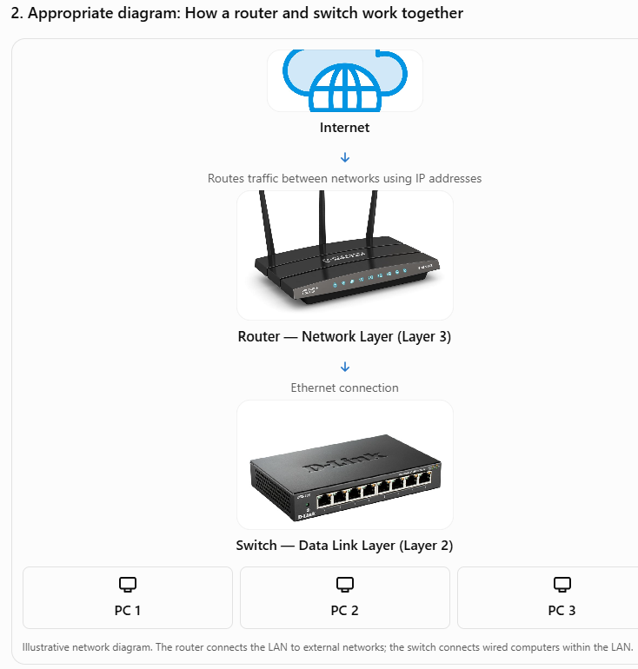

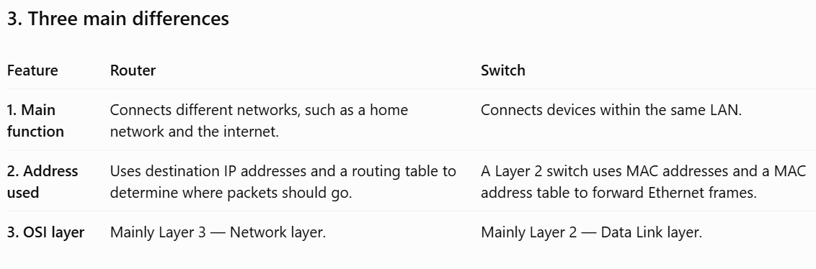
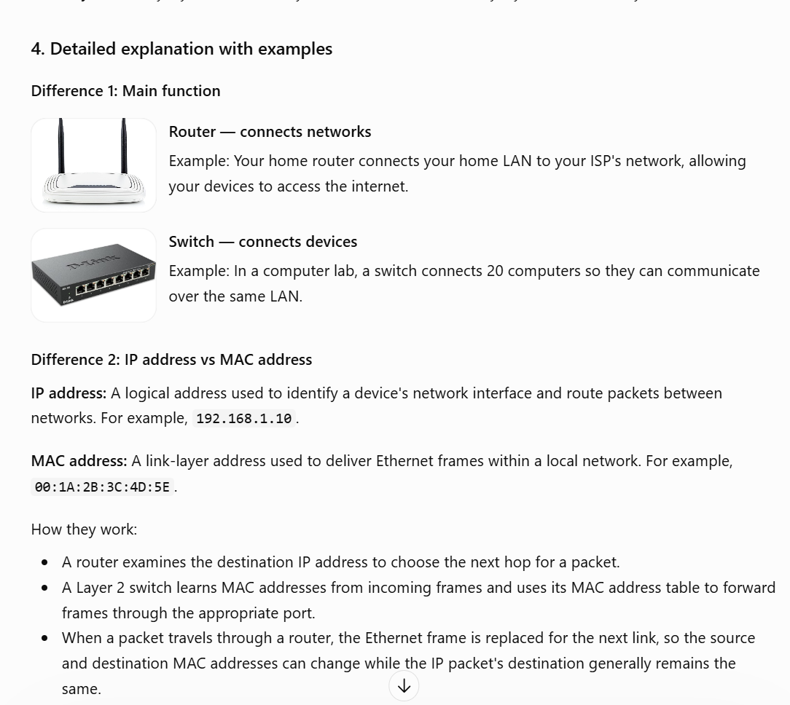

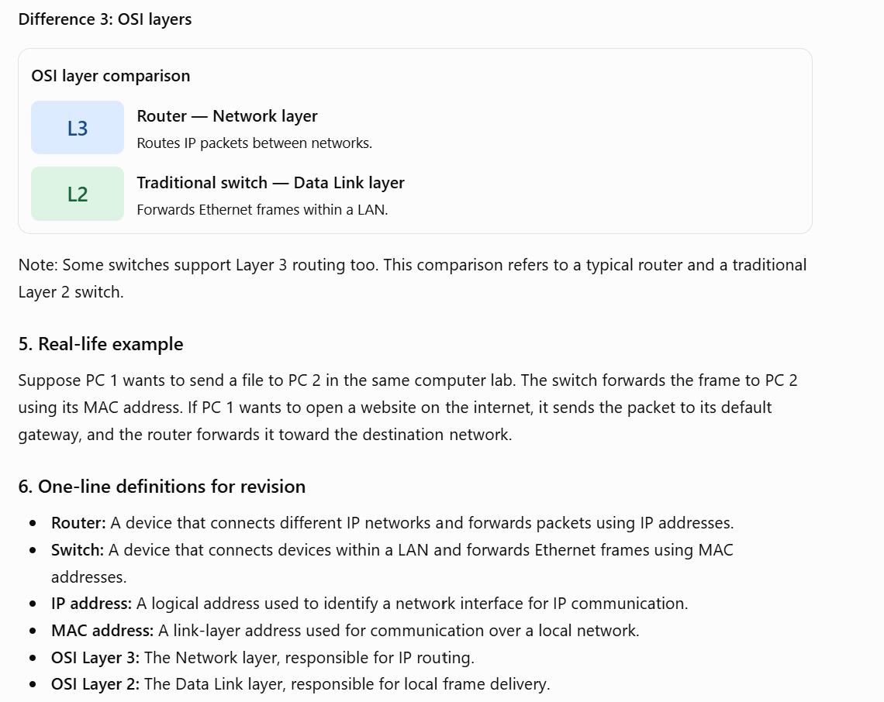
Conclusion: A router connects networks, whereas a switch connects devices within a network. Both work together to provide communication between local devices and the internet.
3.Take a real or virtual image of a router and a switch (from your home, lab, or Google Images), and identify the following on each: Power port, at least 2 Ethernet ports, and any LED indicators. Annotate the image or describe their position and purpose.
Identify Ports and LEDs on a Router and a Switch
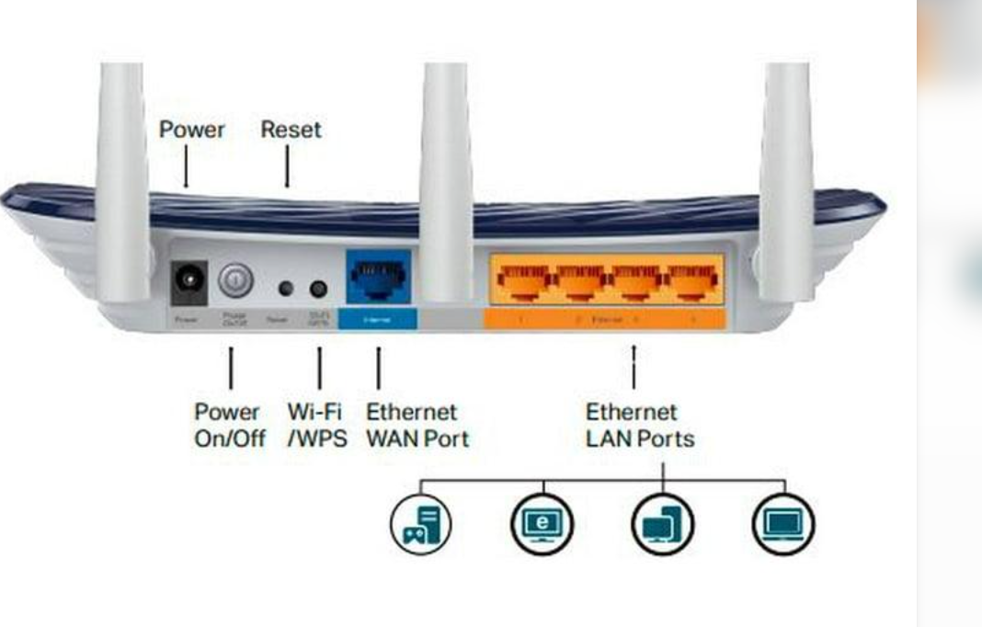
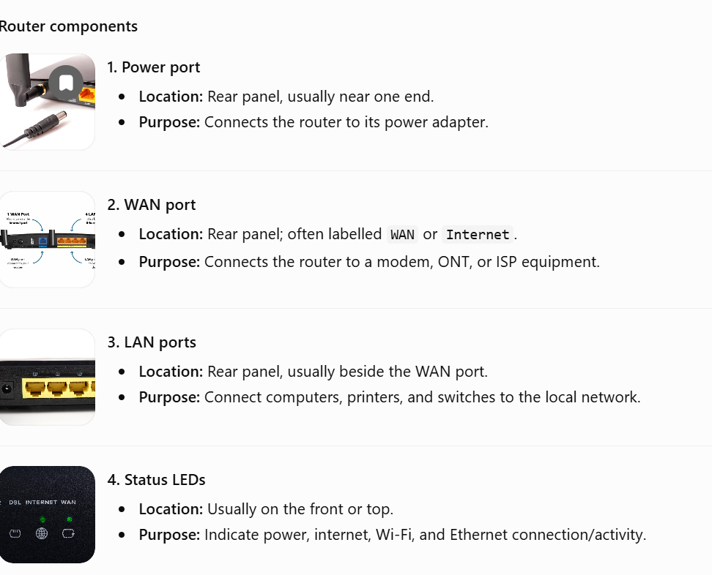
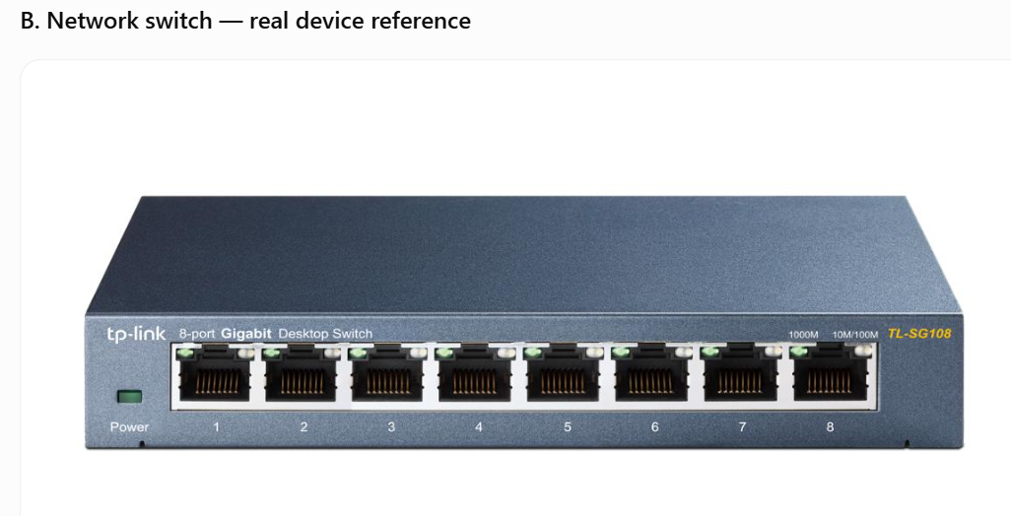
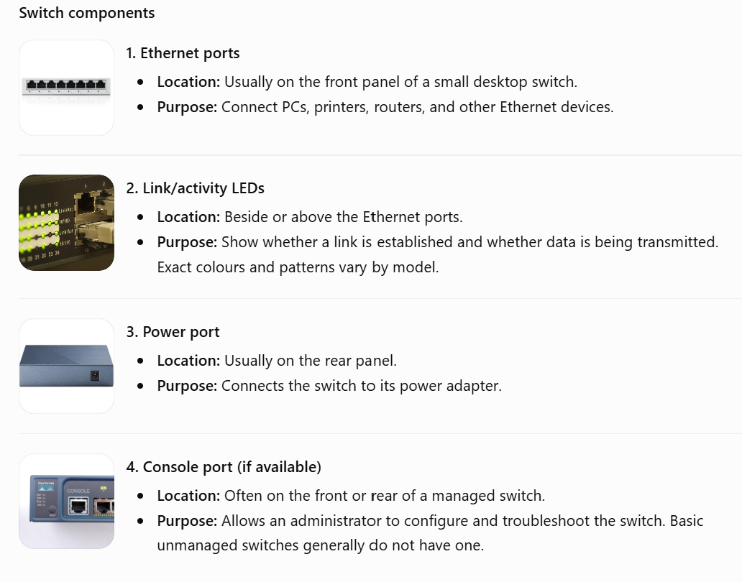
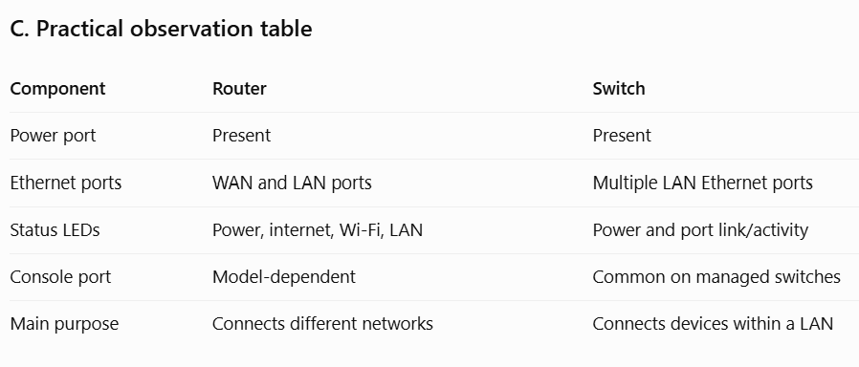
Conclusion: A router's WAN and LAN ports connect external and local networks, respectively. A switch's Ethernet ports connect multiple devices within a LAN, while its LEDs indicate connection status and activity.

4.Imagine you are setting up a small gaming café network for IPL streaming and multiplayer matches. Write a short scenario explaining which device (router or switch) you would connect first to the ISP line, and how you would connect 8 gaming PCs to the network. Justify your choices.
1. Scenario
Imagine I am setting up a small gaming café with eight gaming PCs. Customers need a stable internet connection to watch IPL matches, play online multiplayer games, and access online services.
I would use a router, a Gigabit Ethernet switch, Ethernet cables, and eight gaming PCs to build the network.
